**Question 1**

Consider an integer array, the number of elements in which is determined by the user. The elements are also taken as input from the user. Write a program to find those pair of elements that has the maximum and minimum difference among element pairs.

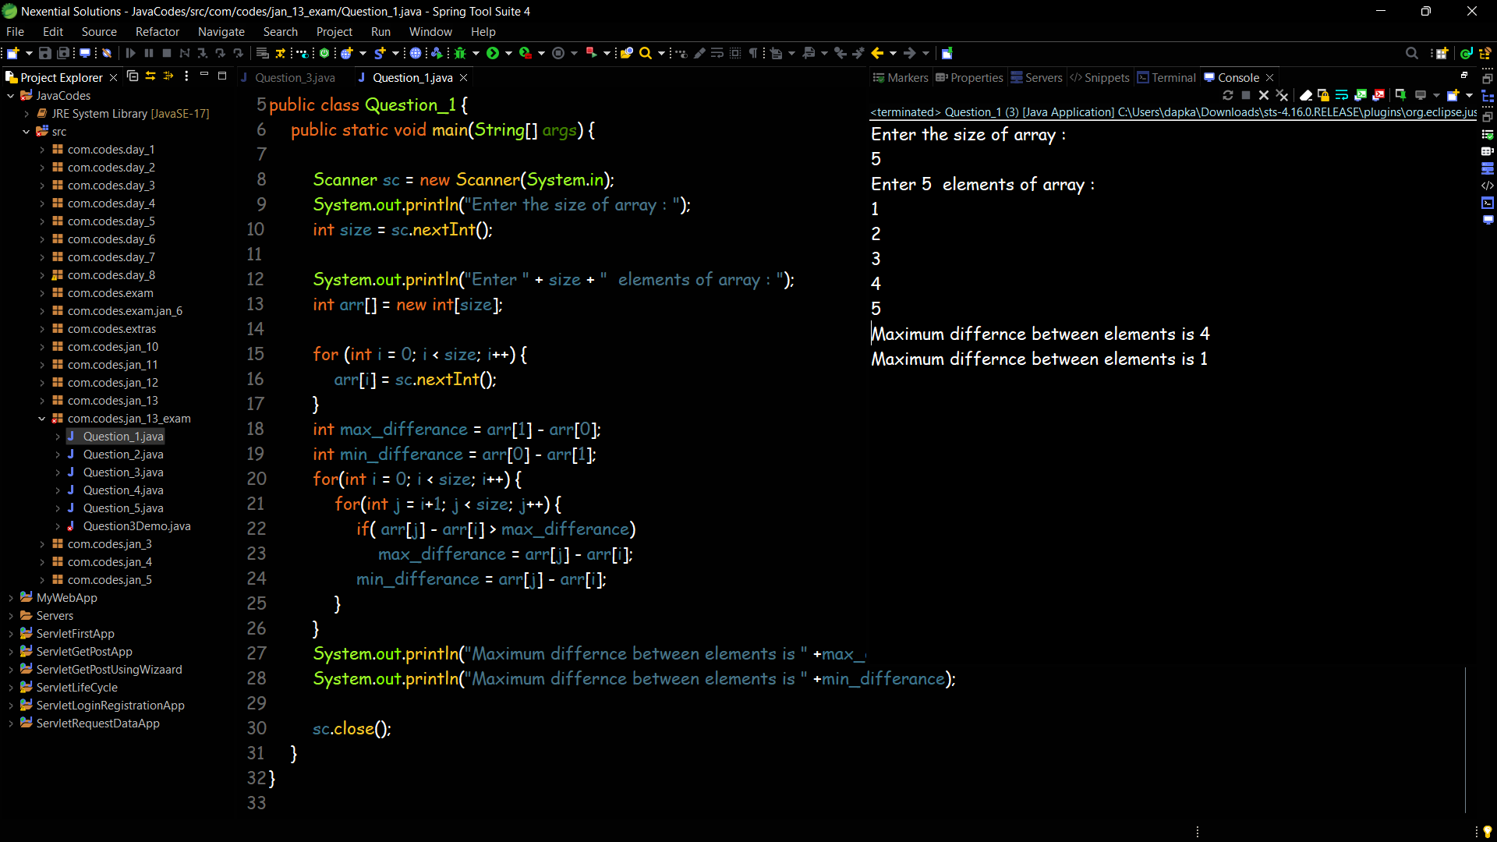

**Question 2**

Write a Java program to remove a specific element from an array and print new array

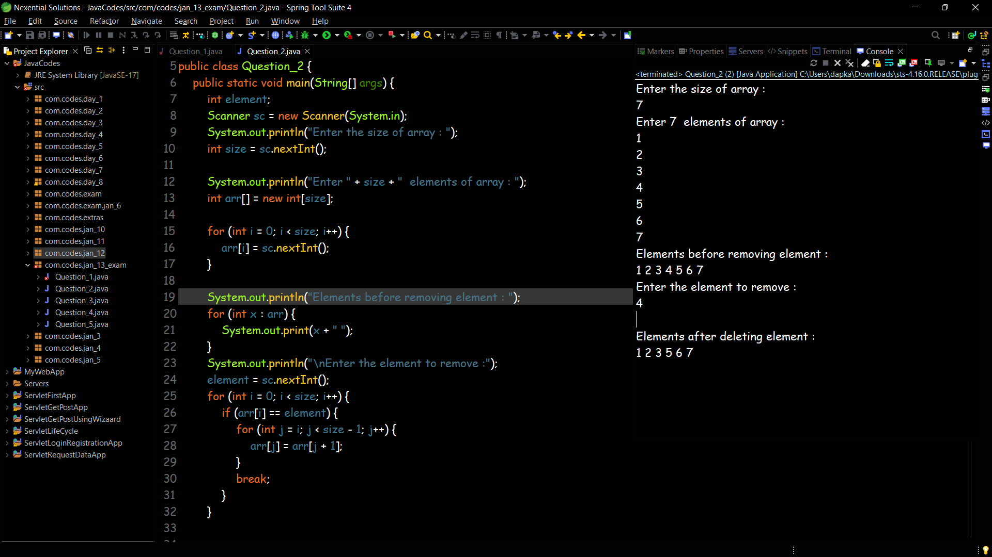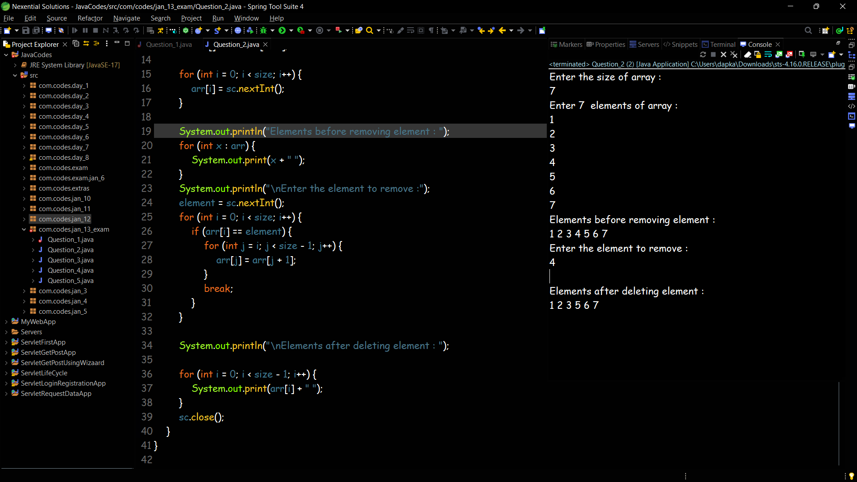

**Question 3**

Input a string of alphabets and store it into an array. Find out the number of occurrence of all alphabets in that string. Find out the alphabet with maximum occurrence.

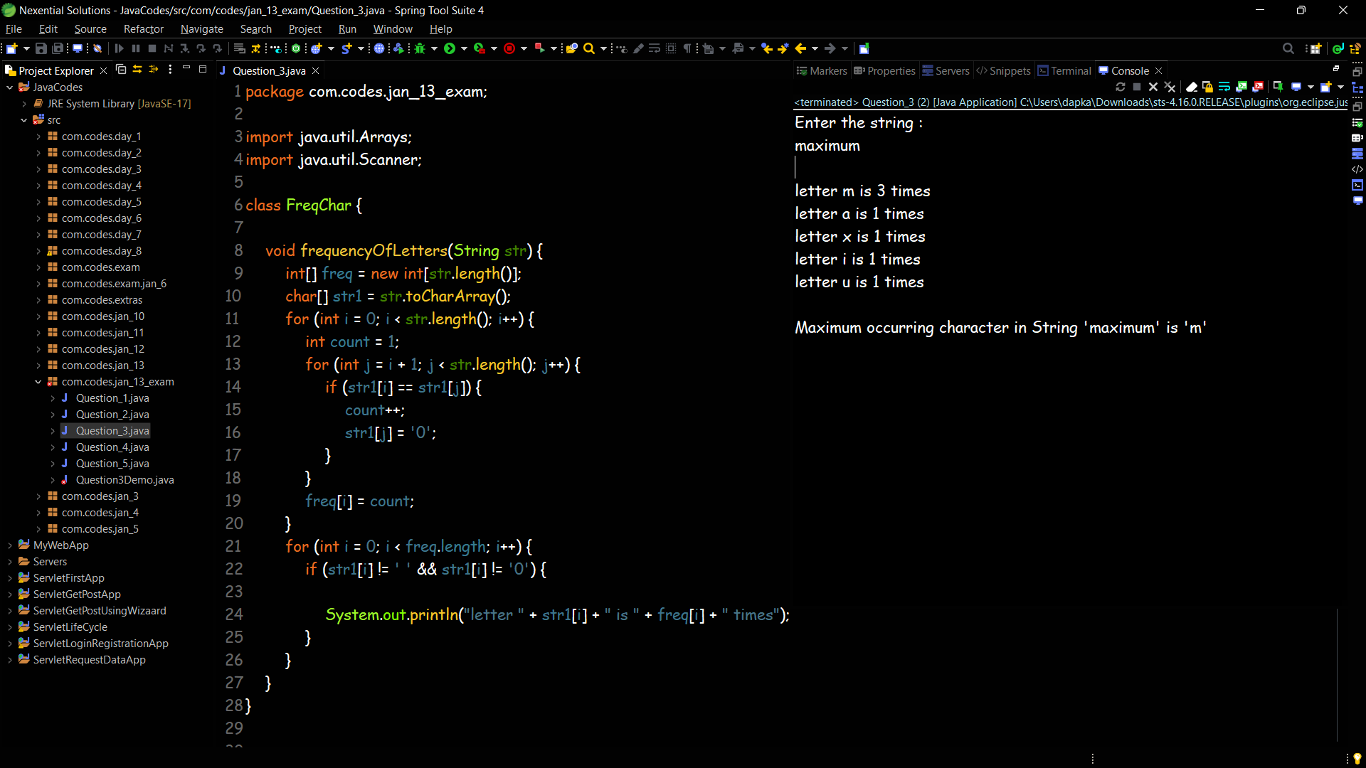

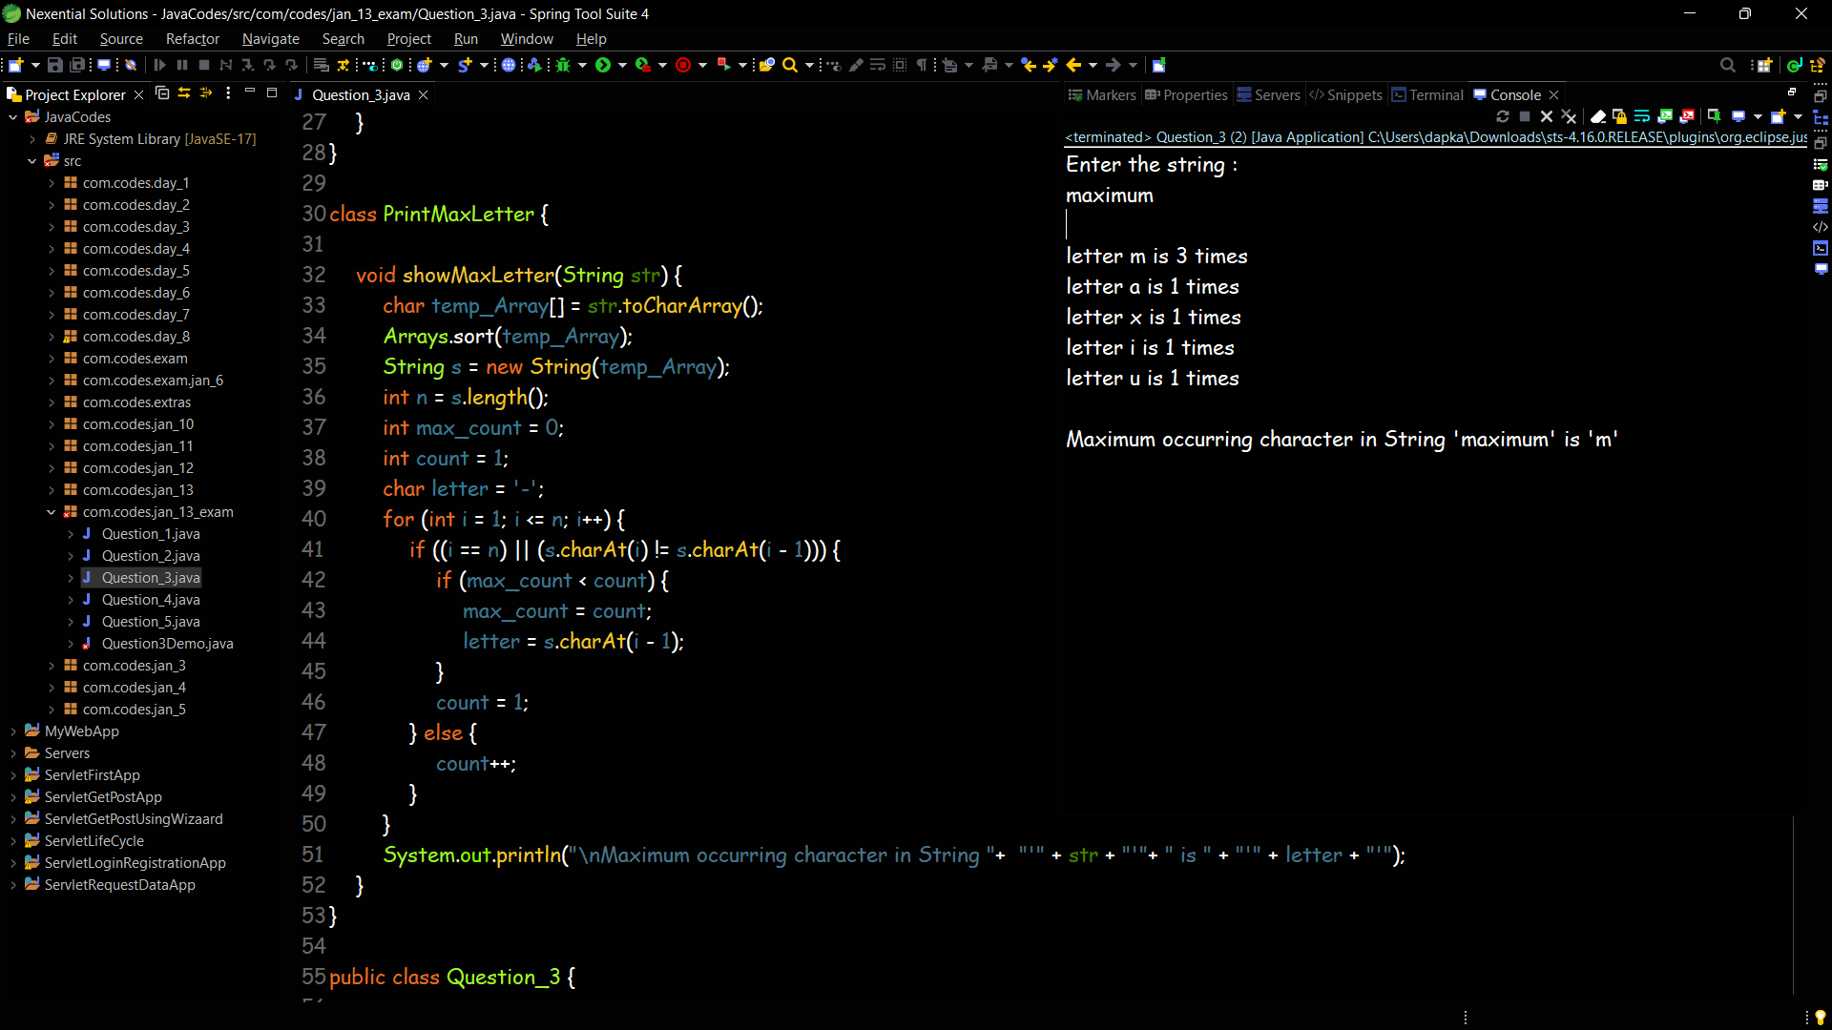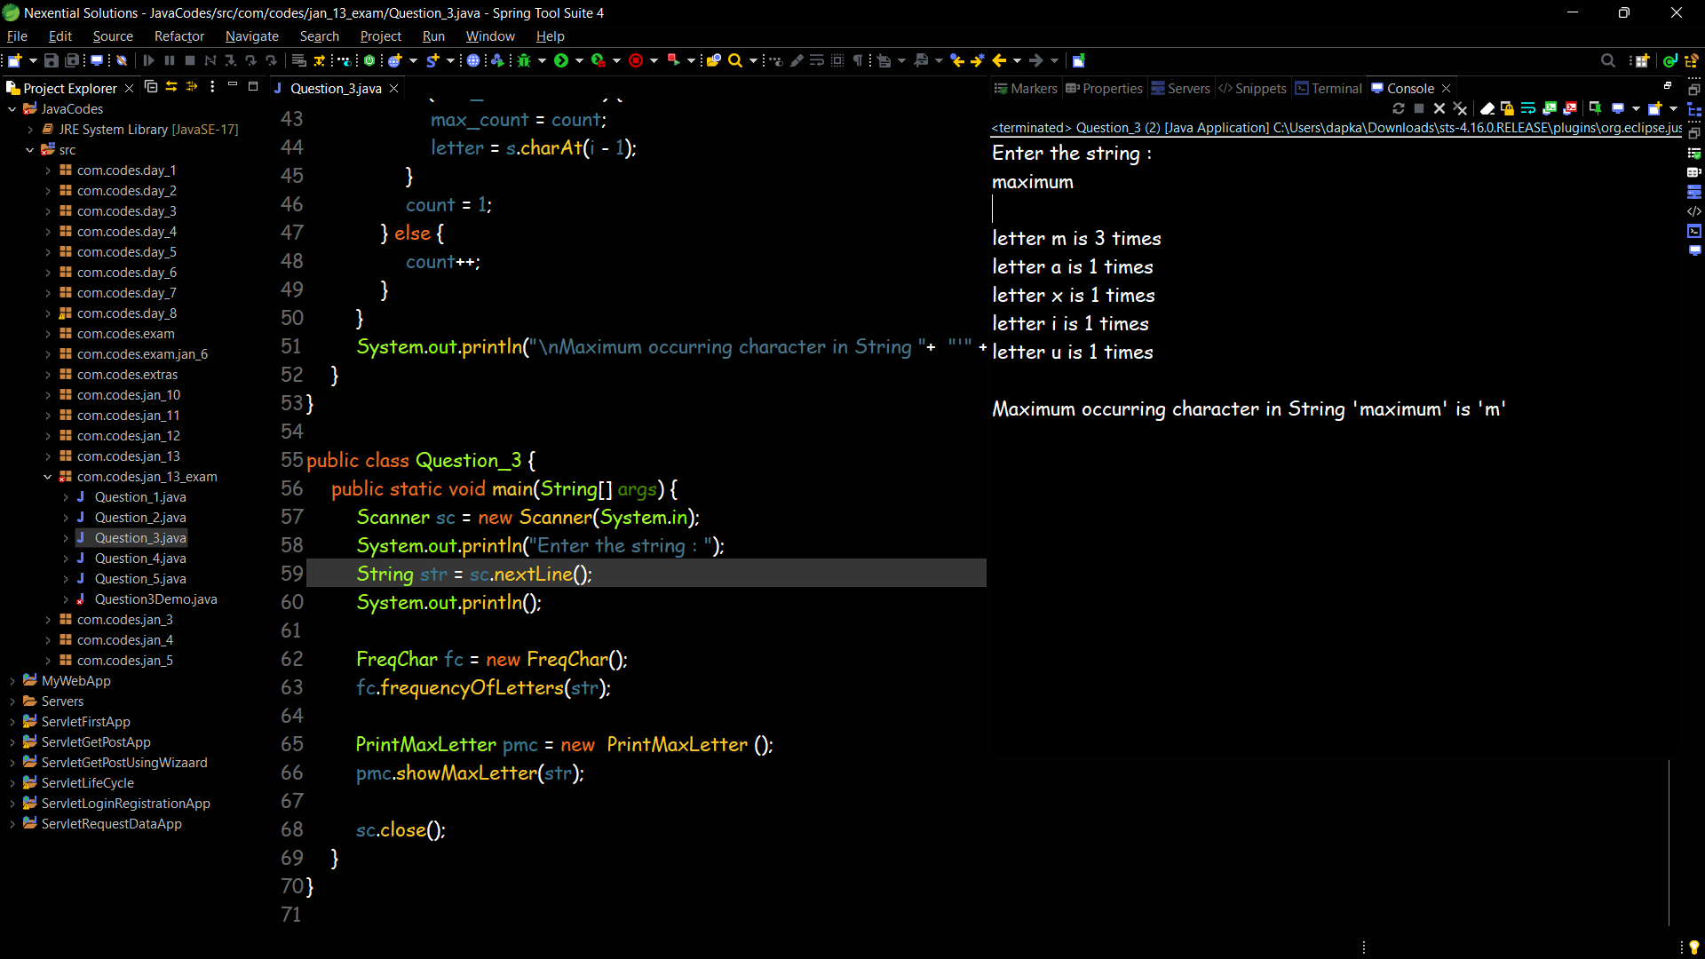

**Question 4**

Write a Java program to multiply two matrices with size 4*4

